**Срок реализации:** до 15 декабря 2015 года

**Объём финансирования:** **1 149 049,74** рублей

**Фото, после выполнения работ:**

[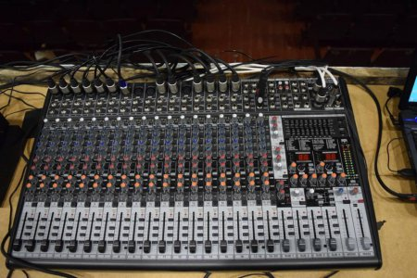](http://oek.su/uploads/posts/2015-12/1450941130_dsc_0209.jpg)

[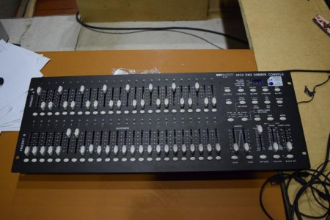](http://oek.su/uploads/posts/2015-12/1450941194_dsc_0211.jpg)

[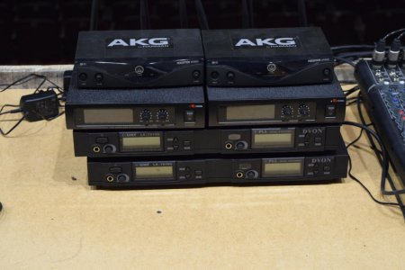](http://oek.su/uploads/posts/2015-12/1450941135_dsc_0212.jpg)

[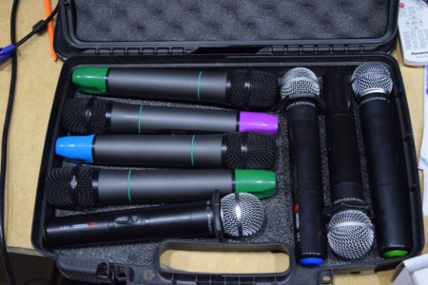](http://oek.su/uploads/posts/2015-12/1450941159_dsc_0213.jpg)

[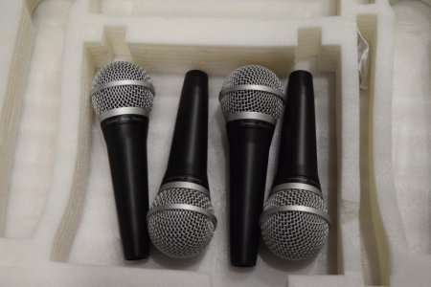](http://oek.su/uploads/posts/2015-12/1450941136_dsc_0214.jpg)

[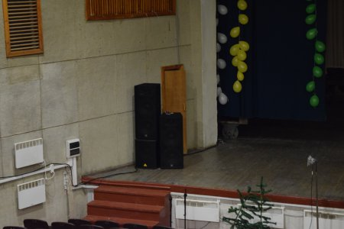](http://oek.su/uploads/posts/2015-12/1450941203_dsc_0216.jpg)

[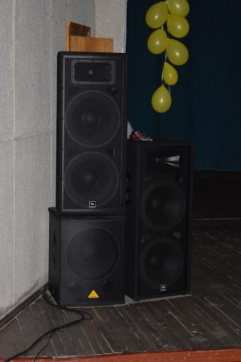](http://oek.su/uploads/posts/2015-12/1450941250_dsc_0217.jpg)

[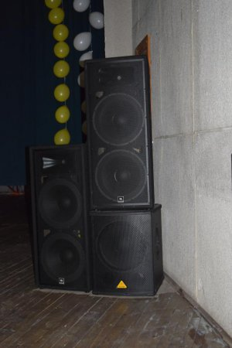](http://oek.su/uploads/posts/2015-12/1450941234_dsc_0218.jpg)

[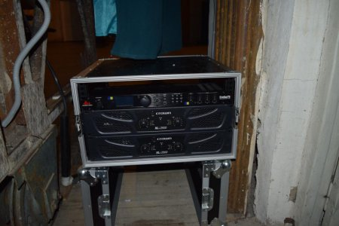](http://oek.su/uploads/posts/2015-12/1450941187_dsc_0219.jpg)

[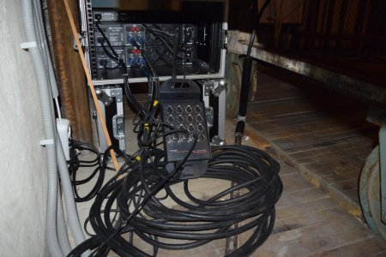](http://oek.su/uploads/posts/2015-12/1450941212_dsc_0220.jpg)

[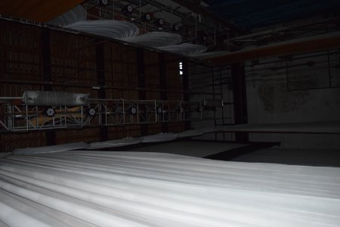](http://oek.su/uploads/posts/2015-12/1450941301_dsc_0221.jpg)

[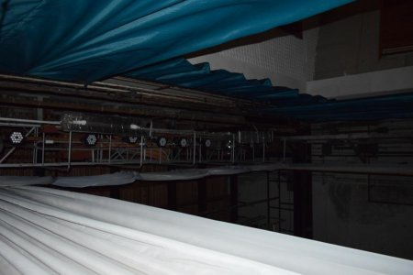](http://oek.su/uploads/posts/2015-12/1450941241_dsc_0222.jpg)

[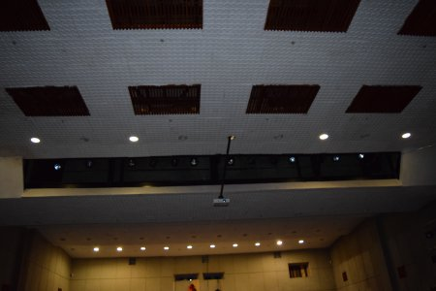](http://oek.su/uploads/posts/2015-12/1450941341_dsc_0223.jpg)

[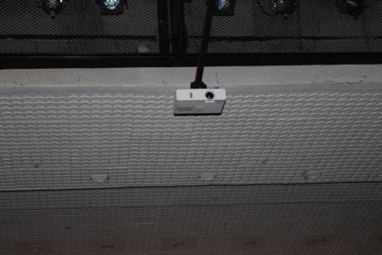](http://oek.su/uploads/posts/2015-12/1450941311_dsc_0224.jpg)

[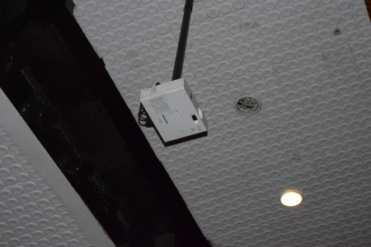](http://oek.su/uploads/posts/2015-12/1450941350_dsc_0225.jpg)

[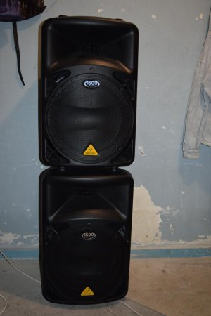](http://oek.su/uploads/posts/2015-12/1450941392_dsc_0226.jpg)

[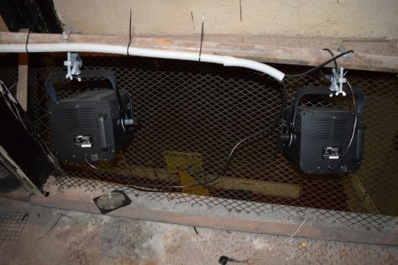](http://oek.su/uploads/posts/2015-12/1450941453_dsc_0227.jpg)

[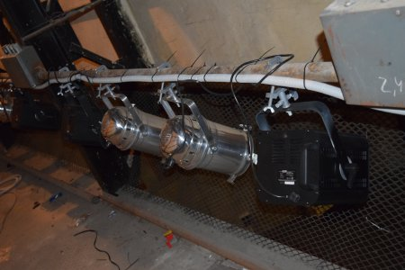](http://oek.su/uploads/posts/2015-12/1450941512_dsc_0228.jpg)

[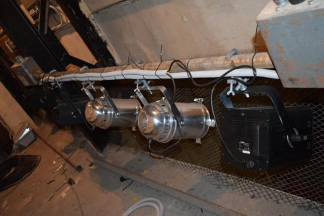](http://oek.su/uploads/posts/2015-12/1450941534_dsc_0229.jpg)

[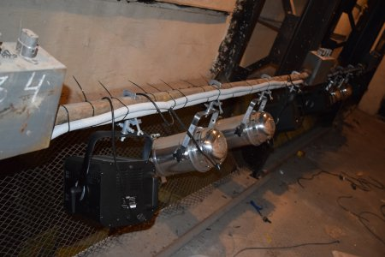](http://oek.su/uploads/posts/2015-12/1450941562_dsc_0230.jpg)

[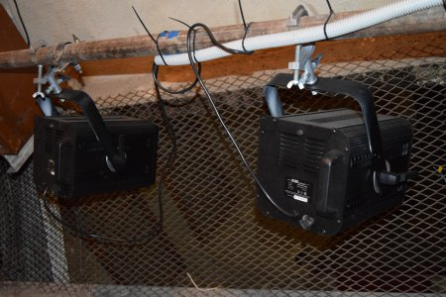](http://oek.su/uploads/posts/2015-12/1450941644_dsc_0231.jpg)

[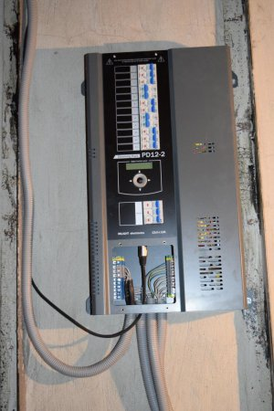](http://oek.su/uploads/posts/2015-12/1450941648_dsc_0232.jpg)

[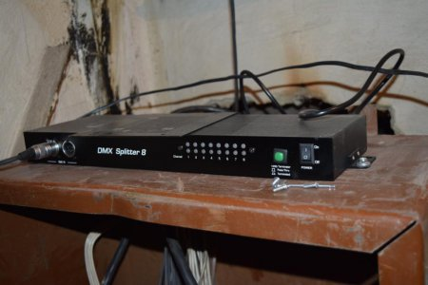](http://oek.su/uploads/posts/2015-12/1450941663_dsc_0233.jpg)

[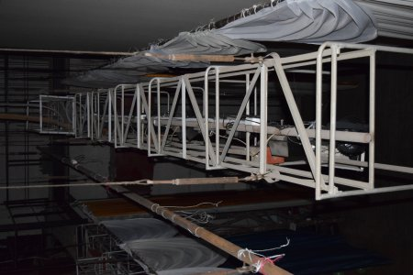](http://oek.su/uploads/posts/2015-12/1450941674_dsc_0234.jpg)

[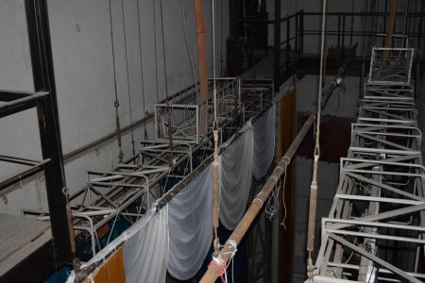](http://oek.su/uploads/posts/2015-12/1450941732_dsc_0235.jpg)

[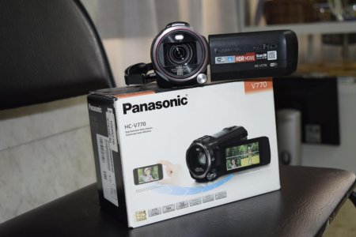](http://oek.su/uploads/posts/2015-12/1450941780_dsc_0255.jpg)

[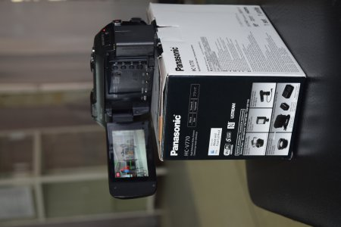](http://oek.su/uploads/posts/2015-12/1450941849_dsc_0256.jpg)

[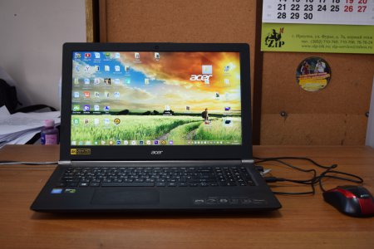](http://oek.su/uploads/posts/2015-12/1450941855_dsc_0260.jpg)

[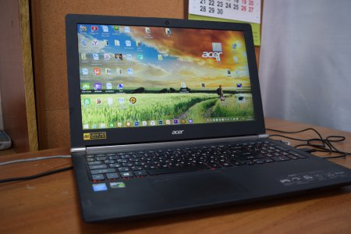](http://oek.su/uploads/posts/2015-12/1450941869_dsc_0261.jpg)

[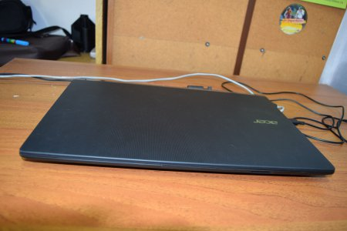](http://oek.su/uploads/posts/2015-12/1450941975_dsc_0262.jpg)

[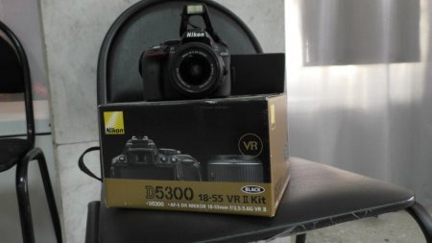](http://oek.su/uploads/posts/2015-12/1450941941_s1300001.jpg)

[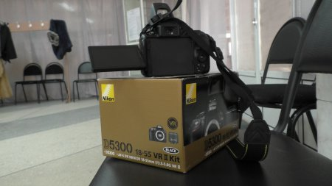](http://oek.su/uploads/posts/2015-12/1450942013_s1300002.jpg)