[[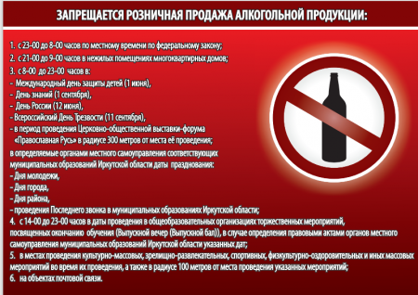](http://oek.su/uploads/posts/2021-09/1631259390_12.png)](http://oek.su/uploads/posts/2021-09/1631259390_12.png)  
[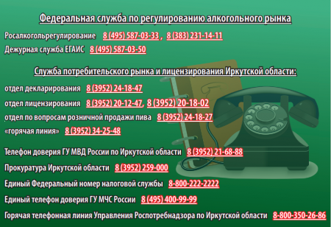](http://oek.su/uploads/posts/2021-09/1631259391_13.png)